**TPS DATA UTILITIES (Version 1.0)**

**Including the MATLAB GUIs “TPS_data_norm” and “TPS_data_utility”**

**William Gray**

**11 Apr 2006**

# Big Picture

“TPS_data_norm” takes any CSV file produced using ILIAD or the C12 data and turns the data into a MATLAB structure for viewing, parsing, and exporting with “TPS_data_utility.”

# Installation

Add the network folder where the files are located to your MATLAB path (using the File: Set Path command in the main MATAB menu. This will ensure you are always using the latest software. If you intend to use these utilities off-line, copy them into a folder on your computer and ensure that that folder is in your MATLAB path.

# Preparing Data

The TPS_data_norm utility is optimized for the CSV file produced by ILIAD for TPS instrumented aircraft and by the C12 data stripping software run by Ray Enriquez. It will work with any comma-delimited data file (preferably with the first row being column names) provided that all rows except the first have numerical data. The text for numerical errors in ILIAD and C12 data are handled automatically by TPS_data_norm.

You can put the CSV file anywhere you have network access, and you can save the result anywhere you have access.

# TPS_data_norm

Start MATLAB and type TPS_data_norm at the >> prompt. You will see this:

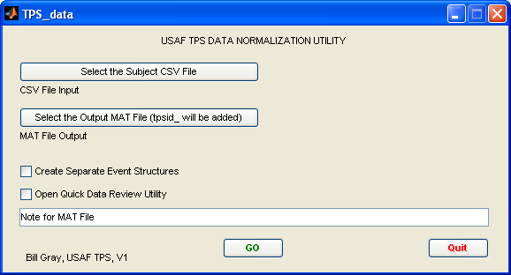

## Selecting input and output files

First click on “Select the Subject CSV File” and use the resulting window to find and identify your file. Once you have done this, the path and filename will appear thusly:

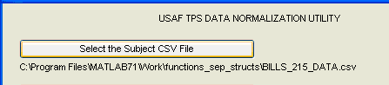

Then do the same to select or create a target data file. The file will start with “tpsid_” but you needn’t enter that—it’ll happen automatically. This identifying text shows that it is a MAT file that is compatible with the “TPS_data_utility.” Once you have done this, the path and filename will appear thusly:

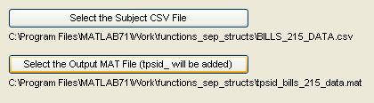

## Selecting additional options

### Create Separate Event Structures

If you check this box, a separate structure will be created for each event number. The reason for this is obvious in the TPS_data_utility. It pre-parses the data into the events you selected in flight.

### Open Quick Data Review Utility

If you check this box, the data review utility (TPS_data_utility) will open when your data is complete. You will still need to select the correct file when it opens, but a GUI is provided.

### Note for the .MAT File

This note will be added to the main data structure ‘all_data’ and displayed in TPS_data_utility.

## Running the data

Just push “GO” You will see a variety of notification windows keeping you up-to-date on the process. A fast laptop will process a 400meg file from the C12 in about 5 minutes. During the processing, you will be asked to select default vectors for display. Choose five using option-click. Once the data is done processing, it will let you know and, if requested in the GUI, open TPS_data_utility.

## Quitting

Just push “Quit”

# TPS_data_utility

This can either be entered from the TPS_data_norm or by typing “TPS_data_utility” at the >> prompt. You will be given a GUI to navigate to and select the file of your choice. The file must start with “tpsid_” to ensure that it is formatted properly.

## Selecting the Plot Parameters

A window showing all data vectors will be presented with your selected plot parameters pre-highlighted. Change them if desired and click “OK.” The parameters you select will be the first ones plotted.

## What is in the GUI

The GUI opens with the first event number (if parsed) or all of the data. Here is an example:

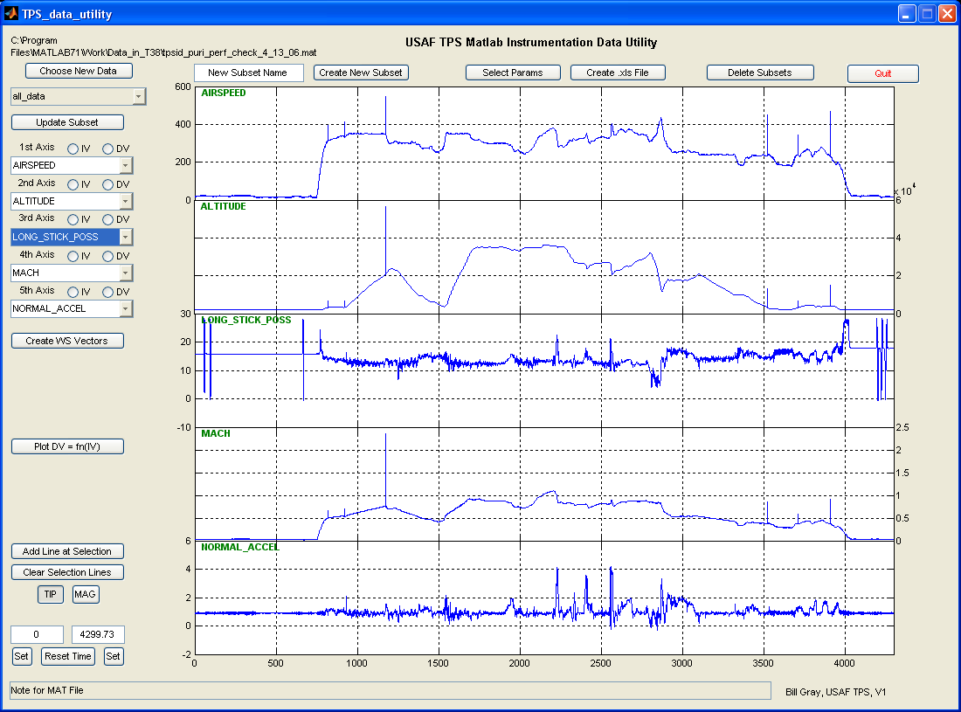

The tpsid file being reviewed and the structure being plotted are in the upper-left-hand corner. Tools for selecting data, changing the time scale, magnifying, and plotting one variable against another are on the left side. Along the top are the utilities for creating new subsets, exporting to Excel, and deleting subsets. The note for the subset is along the bottom of the GUI.

## Choosing a different tpsid data file

Click on the button and a GUI will open allowing you to select a new file. It is highly unlikely that a file not notated with tpsid will work with this tool.

## Choosing a different subset

All available subsets in the current tpsid file are listed in a pull-down menu with the current one displayed. Note that selecting a new subset does not save any changes you made to the previous one—you need to use “Update Subset” for that.

## Changing the charted data

Pull-down menus are used to select the data depicted in each chart. You can display the same data on multiple graphs.

## Changing the time range

This can be done several ways. First, type a new start or end time in the appropriate window and tab out or hit the enter key on you keyboard. Second, use the datatip or magnification tool as described below.

When you change the time range, it is changed for all charts but does not change the data in the subset. You can reset to show the entire time range of the data subset by clicking “Reset Time.”

## Updating the subset

If you like the time range for the subset and the vectors currently displayed and want to get rid of the outlying data (crop), you can click on “Update Subset” to save only that time range and to save the displayed vectors so that they will automatically come up next time you open the subset. If you changed the time range using the magnification tool but didn’t “Set” the new times in the time range windows, “Update Subset” will remind you to do so first.

Until you update a subset, you can always reset to the original time range. Once you update, you lose all data outside your new time range. (But the ‘all_data’ subset will still have that data.)

## Plotting one variable against another

If you select an independent and dependent variable using the buttons above the data selectors, you can click on “Plot DV = fn(IV)” and in a few seconds the plot will appear. You can create as many of these as you like and close them by clicking on ‘X’ in the upper-right-hand corner.

## Using the datatip and magnification tools to examine data

You can select to use either the datatip or the magnification tool by clicking “TIP” or “MAG” (it opens with “TIP” selected.)

The datatip tool shows a ‘plus’-shaped cursor that, when you place it near a data trace and click, the nearest datapoint is highlighted and its x and y values shown.

The magnification tool is selected by clicking “MAG.” A magnifying glass cursor appears and you can click-and-drag a box around the data you want to examine. When you release the mouse button after highlighting the data, the data trace will magnify to the selected area, the remaining four data traces will zoom to the same time frame and will also reconfigure the automatic y scale. (Changing the y scale aside from the magnification tool has yet to be developed but is on the list of future improvements.)

### Using the datatip to compare times of different events

When you have a data point selected, clicking on “Add Line at Selection” will draw a vertical red line through all five plots. You can do this repeatedly, adding red lines to your heart’s content. If you change ANY of the charts in any way (magnify, choose a new start or end time, or choose a new vector for display) all of the red lines will be erased.

You may also erase your lines by clicking “Clear Selection Lines.”

### Using the datatip to change start and end times shown

If you have selected a data point, you can make its time value the start time or end time by clicking the “Set” button under the appropriate time. Once you do this the time is changed, the time scale is changed, and the charts are replotted. (Click “Reset Time” to reset to the entire subset time scale.)

### Using the magnification tool to change the start and end times

When you have magnified a vector using the magnification tool, the start and end time displays do NOT change to match the displayed y scale. Click on either “Set” button to make this happen. If there is a mismatch between the numerical displays and the displayed scale, you cannot export the data to Excel, save a new subset, or save the subset changes.

## Changing the note

You can modify the note at any time. When you do, the new note is immediately saved to the original .mat file so it may take a few seconds for a subset with a lot of data.

## Unlocking Special Exporters

If a routine has been built to export data for a specific short-term project, you can make the export button visible by tying the correct text into the “New Subset Name” box and tabbing out or clicking on a new box. The button with your command will appear below the “Create WS Vectors” button.

## Creating a new subset

If you want to create a new subset, use the time span tools to set the time span you want and make sure you are displaying the vectors you want as the default display vectors. Enter a name in the “New Subset Name” box then click on “Create New Subset.” You will be asked to enter a note (you can leave it as “none”) then the new subset will be saved. For large data sets this can take a few seconds—wait until the dialog box closes.

## Exporting Data to Vectors in the Workspace

You can export any data to individual vectors in your current MATLAB workspace by clicking the “Create WS Vectors” button. You will be given a list of the data parameters with the displayed parameters (and running time) pre-selected. Select what you want exported and click OK. Your vectors will be waiting for you when you return to your workspace.

## Creating an Excel file

When you have a time range you like and want to create an Excel file with the data in that time range, use the “Create .xls File” utility. You should set the parameters first (unless you want all data parameters in the Excel file!) The independent variable time parameter will always be included in your excel file. Click on the “Create .xls File” utility and your xls file will be created. (Enter a name in the “New Subset Name” box first.) Note that if you data exceeds32000 rows, it will automatically be reduced to no more than 32000 rows by taking every nth row. A message box will appear to show you that this is being done.

The file is complete when the “please standby…” message box closes.

### Selecting the parameters for the Excel file

Click on “Select Params” and option click the parameters you want to export. Click OK when done. (Note that the parameter selection is only active for xls files. All parameters are saved in new subsets.)

## Deleting subsets

You can delete any number of subsets by clicking on the “Delete Subsets” button. You can option-click to select multiple subsets and will be asked to confirm your choices. There is no undo. But IF you have not deleted the “all_data” subset you still have the data—you just need to create a new subset.

## Things you cannot do with this tool—yet

1. Delete individual data points.
2. Delete all the data points for a given time (aside from cropping)
3. Magnify more than one graph at a time (aside from the time range)
4. ***Your comments here*** (see MAKING IT BETTER)
5. Wheel
6. Soar
7. Swing
8. …and a hundred other things!

## Quitting the application.

Click ‘Quit’ and check the beer light at the ops desk. If it is on, have a beer!

## MAKING IT BETTER

Email ideas to Evil at [william.gray.15@us.af.mil](mailto:william.gray.15@us.af.mil).